Imię i Nazwisko Piotr Heinzelman  Grupa index 146703 Twoje ABCDA=2,B=2,C=6,D=1  Data wykonania 21.I.2024 | 

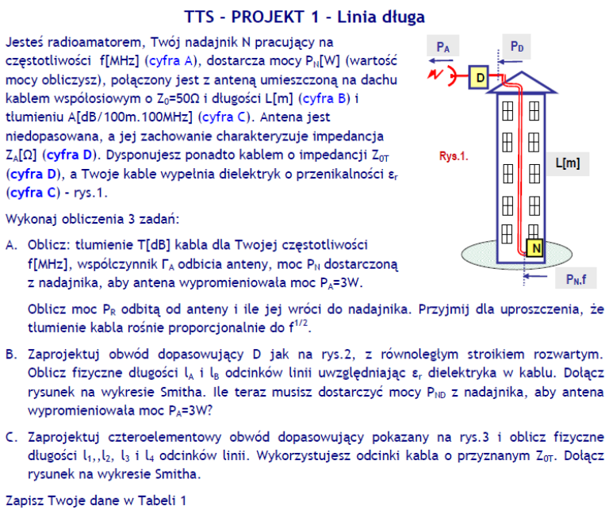
f[MHz] | L[m] | A[dB/_{100m}._{100MHz}] | Z_{A}[Ω] | Z_{0T}[Ω] | ε_{r}
425 | 27 | 11,6 | 20+j70 | 88 | 2,5
Końcowe obliczone parametry wpisz do Tabeli 2
T[dB] | P_{N}[W] | P_{R}[W] | l_{A}[mm] | l_{B}[mm] | P_{ND}[W] | l₁[mm] | l₂[mm] | l₃[mm] | l₄[mm]
6.4568 | 32.5062 | 0.9836 | 199 | 93 | 13.27 | 27 | 146 | 154 | 126

